CARD 13
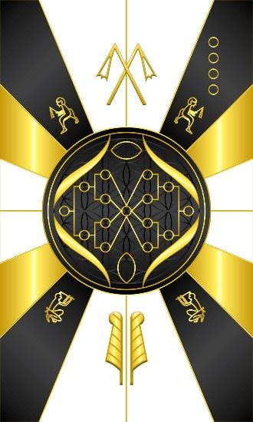
Card 13 is Sheps or the Egun, collective group of enlightened ancestors and dark deceased. At the top we have the traditional Egyptian hieroglyph of the honored ancestors holding the flail, and at the top of the card we have the flails. It is a sign of dominion and leadership through outer show of force, but this is the force of Heru, the Will, who declares his authority by being an exemplar of strength of character, and the rule of truth. This is we use it to represent enlightened ancestors, those who have lived and shown good character in their lives. Although all ancestors have the potential to function as unifiers of the people at different levels, not all of them do so. Only such people who lived up to the standards imposed by Tehuti, The Great Shpes in Khemennu, earned the right and privilege to become Sheps, the honored living or honored dead. The almond shape at the top of the circle represents the eye as an organ that processes light, and the insight gained from following the advice and examples set by our honored enlightened ancestors.
At the bottom is the hieroglyph for the dark deceased, depicted with an axe through the head. When we have dark deceased they are not at peace and were subject to certain vices that they had trouble with during their lifetime. They attach themselves to individuals and feed off those same vices, but it is the goal of the individual to help that ancestor move on, but learning how to live truth in those moments, so as not to give in to the vices. Living truth is Maat, which is symbolized by her feathers. The almond shape at the bottom represents the womb or birth canal, the ability to plant seeds and the means by which one can give birth to new things. By planting the appropriate seeds, we give birth to new behaviors that enables us to live truth at the crossroads and thereby help the corresponding ancestor to move on.

In the middle, I could not find an example of an image that conveyed the idea of ancestral lineage, but what came to mind was using the often seen example of an ancestry chart showing the placeholder of an individual and their parents. For example, the small circle on the right represents the male principle, and on the left, the female. Then, we have an extension that shows the relationship to their parents, and their parents, each have parents, which represent grandparents in the bloodline, but beyond the bloodlines, we also see ancestral ties that extend beyond bloodlines in the middle. When two people or things are wedded together, whether it be a business, part of a group, friendship, etc. there are bonds that extend beyond just bloodlines and that is what the lines merging in the middle circle represent. On the sides we have DNA strands that will come together, and on Card 10, I wanted to modify that card and depict the DNA strands, the bonds having came together, whereas on this one, the bonds and potential bonds.

Comments by Baba Awodele

